1. What's the best caption to represent this picture?  
   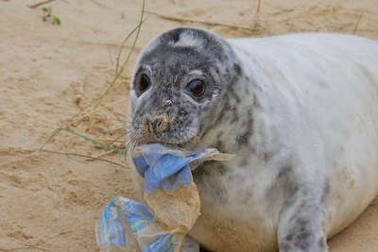  
   1. Let’s go shopping
   2. Good morning fellas!
   3. Hey! I got new souvenir
   4. We need to reduce the plastics
2. Which caption is the best to represent the picture?  
   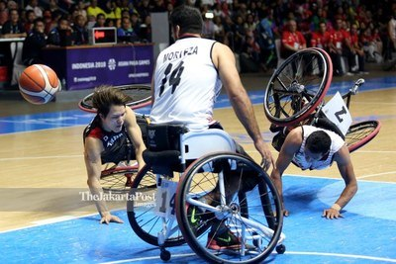
   1. I need to win Asian Para Games basketball to buy new wheel chair
   2. Practice makes perfect
   3. Are you okay bro?
   4. Basketball competition in Asian Para Games
3. **The following captions are suitable, except ....**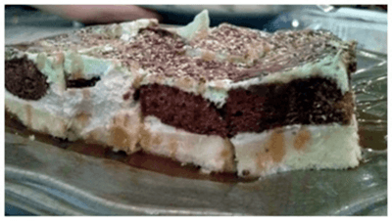
   1. The softest layered cake in town
   2. Try one and you will be fed up.
   3. Vanilla or Chocolate? Why not both.
   4. Try one and you will try more.
4. **The best caption for the picture is**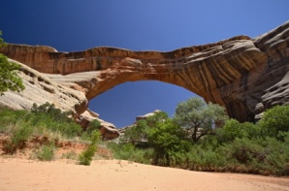
   1. A beautiful landscape
   2. The most blue ocean
   3. A beautiful natural bridge in China
   4. The Suramadu bridge
5. **What does the caption remind us to do?**
   1. Avoid yourself from talking about someone else
   2. Be careful to one who tells you about someone else
   3. Feel happy when someone tells you about someone else
   4. Feel good when someone talks about someone else
6. **The caption above gives us a motivation not to ... because someday we will get success**
   1. go on taking action
   2. carry on moving
   3. easily give up
   4. keep trying
7. **The caption indicates that ...**
   1. It is only you that can have the peace for your own
   2. You cannot have the peace in your own heart
   3. Everyone can bring you the peace in your hard
   4. Anyone else can give the peace for you but you cannot
8. **what is the suitable caption for the picture?**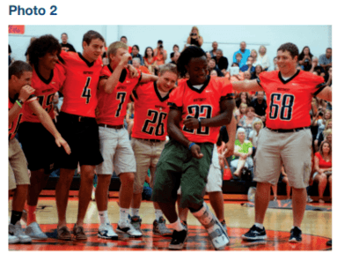
   1. Lovell Jones is dancing to “Stanky Legg.”
   2. The football team lost the game, 21-10
   3. Their music for this season’s show features songs from the movie Jekyll and Hyde.
   4. Junior Emily Daly and junior Daniella Lyons (Daniella is in the front).
9. **Lunar New Year. A giant dragon was shown to the public in the last Chinese New Year in Hong Kong. The city is preparing for the coming Lunar New Year. Authorities said that this year’s celebration would be more spectacular than the last year’s. workers are still installing thousands of lights and lanterns along the streets. The government expects this year’s celebration will attract more than 5 million visitors.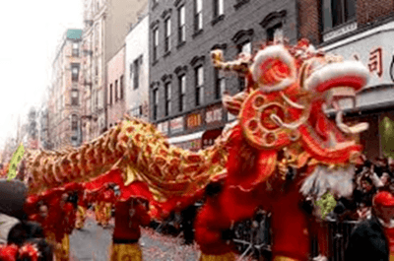 What makes the government expect this year’s celebration will attract more than 5 million visitors?**
   1. A giant dragon show is the main show in the celebration.
   2. This year’s celebration attracts many tourists to come.
   3. The government spends a little money for the celebration.
   4. The last year’s celebration was not spectacular
10. **Maya, right, a young dotted jaguar, walks by the side of her mother in the Nyiregyhaza Animal Park in Nyiregyhaza, 245 kms east of Budapest, Hungary, Thursday, April 28, 2005. It is the first jaguar to be born in a Hungarian zoo for twenty years. Maya's parents have black fur, but her fur will remain dotted according to experts of the zoo. The cub is raised by her mother only, the father is kept separated.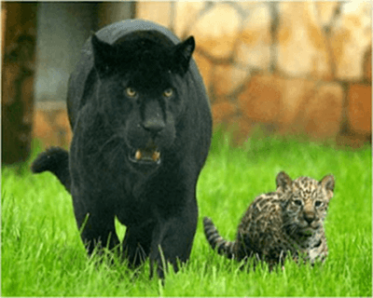 The correct statement based on the text is …**
    1. The cub is raised by both parents.
    2. The experts of the zoo declare that Maya will remain dotted
    3. Maya is the second jaguar born in the Hungarian zoo.
    4. Maya has black fur.